**How to enable cache on Docker MYSQL instance**

Notes: The following commands are executed in Docker console after starting ml

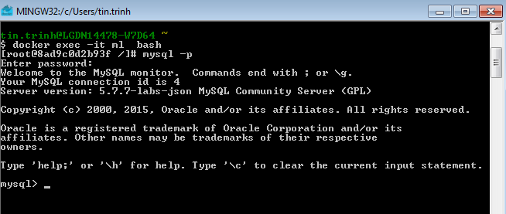

1. **Check that query caching is available**

mysql> show variables like 'have_query_cache';

+------------------+-------+

| Variable_name | Value |

+------------------+-------+

| have_query_cache | YES |

+------------------+-------+

1. **Check that query_cache_type is on**

mysql> show variables like 'query%';

+------------------------------+---------+

| Variable_name | Value |

+------------------------------+---------+

| query_alloc_block_size | 8192 |

| query_cache_limit | 1048576 |

| query_cache_min_res_unit | 4096 |

| query_cache_size | 8388608 |

| query_cache_type | ON |

| query_cache_wlock_invalidate | OFF |

| query_prealloc_size | 8192 |

+------------------------------+---------+

If query_cache_type is OFF, go to the step **#3**

1. **Enable query_cache_type**
   1. Go to Virtual Machine terminal from main docker screen

docker exec –it ml bash

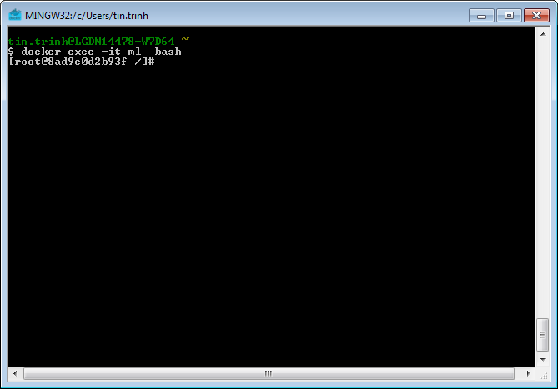

* 1. Edit /etc/mysql/my.cnf file

vi etc/mysql/my.cnf

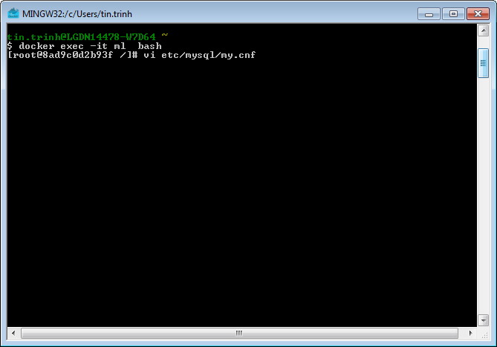

* 1. Add the following settings to /etc/mysql/my.cnf file

query_cache_size = 268435456

query_cache_type=1

query_cache_limit=1048576

In Vi editor:

1. Move cursor to under the line that has [mysqld]
2. Insert new line: shift + o
3. Type:

query_cache_size = 268435456

query_cache_type=1

query_cache_limit=1048576

1. Save and exit: esc -> :wq
2. Use “cat etc/mysql/my.cnf” to review file
   1. Restart ml in docker

docker restart ml

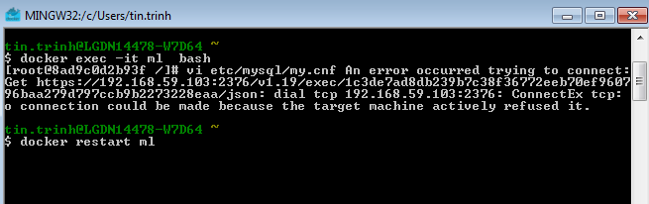

* 1. Go to mysql and check that ‘query_cache_type’ is on

mysql> show variables like 'query%';

+------------------------------+---------+

| Variable_name | Value |

+------------------------------+---------+

| query_alloc_block_size | 8192 |

| query_cache_limit | 1048576 |

| query_cache_min_res_unit | 4096 |

| query_cache_size | 8388608 |

| query_cache_type | ON |

| query_cache_wlock_invalidate | OFF |

| query_prealloc_size | 8192 |

1. **Check that cache is working**

mysql> SHOW STATUS LIKE 'Qc%';

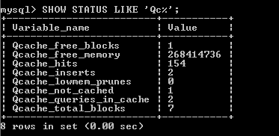

The values of variable_name will be increased when we call queries in the databases of ‘boot2docker-vm’ virtual machine.

**What is next?**

Editing files within the docker container is bad practice. We should use the -v (volume) option to include a config directory with the additional config file. However, the following problem needs to be fixed first.

Problem:

1. The mysql-labs doesn’t pickup the query_cache_type setting

Notes:

1. The config folder needs to be under your Windows User folder (the user running docker)  
   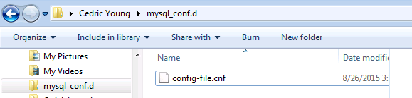
2. For Windows, you need to use ‘//c/Users/’ a double-// and absolute path to the config folder  
   docker run -v //c/Users/[username]/msql_conf.d:/dest.d -p 3306:3306 --name ml -e MYSQL_ROOT_PASSWORD=[sql password] -d mysql/mysql-labs:5.7.7-json
3. The mysql-labs docker container is missing the following line at the end of /etc/mysql/my.cnf  
   !includedir /etc/mysql/conf.d